# Mechanical Design Portfolio

Name: P. Ravi

Role: Junior Mechanical Designer / Konstruktor

Tools: SolidWorks | Assembly Design | BOM | Technical Drawings | SolidWorks Simulation (FEM) | SolidWorks Flow Simulation (CFD)

## Profile

Junior mechanical designer with hands-on experience in SolidWorks assembly modeling, technical drawings, BOM creation, and engineering validation using FEM and CFD. Portfolio projects include electromechanical products, gearboxes, robotic mechanisms, vehicle structures, and concept CAD models.

## Core Engineering Modules

### Module 1: Servo Motor – Electromechanical Assembly Design

Detailed electromechanical servo motor assembly modeled in SolidWorks. Includes DC motor components, gear reduction system, output shaft, bearings, housing, and fasteners. Exploded views, top-level BOM, and assembly drawings were created following ISO drafting standards.

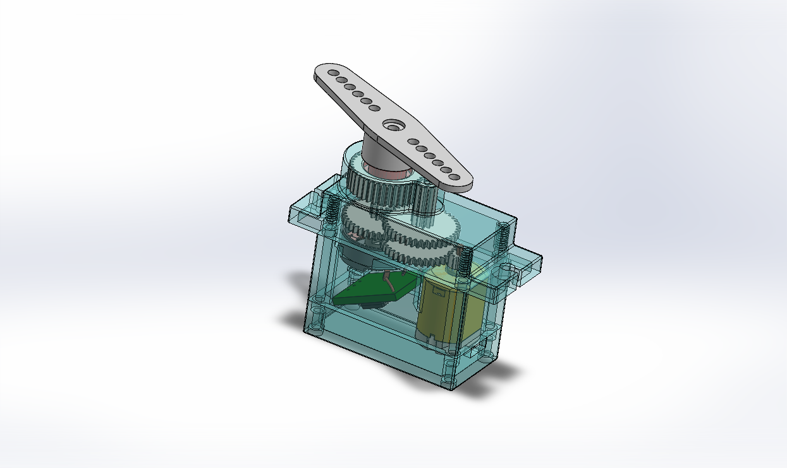

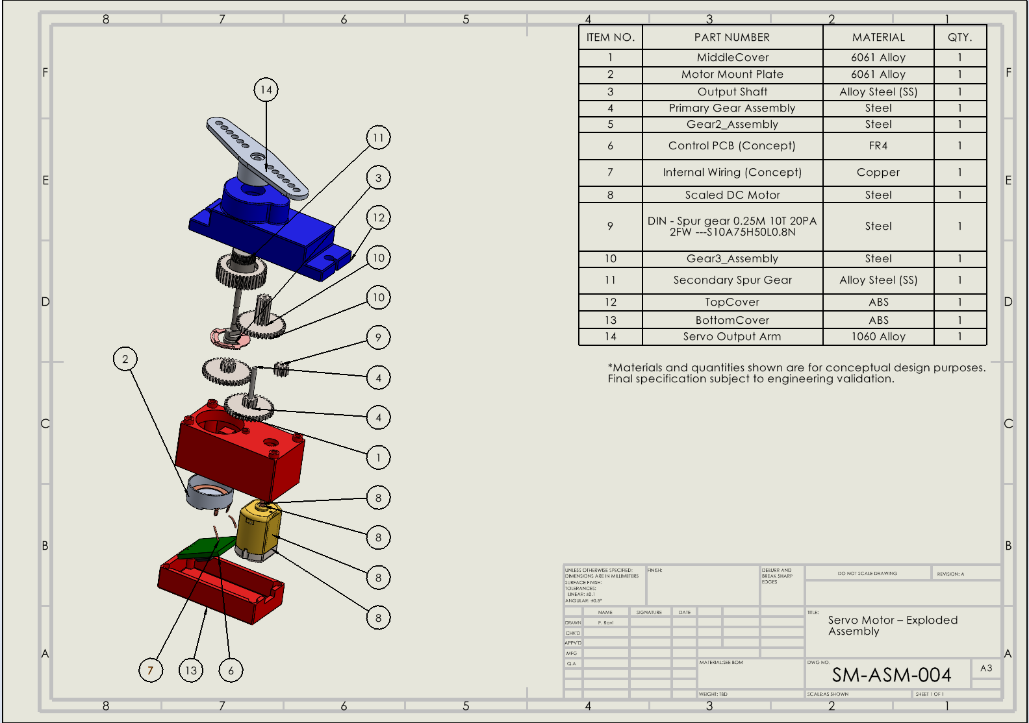

### Module 2: Differential Gearbox – Mechanical Assembly Design

Conceptual differential gearbox designed to demonstrate understanding of power transmission systems. The assembly includes bevel gears, spider gears, shafts, housing, and internal layout. Assembly drawing, section views, and BOM were prepared.

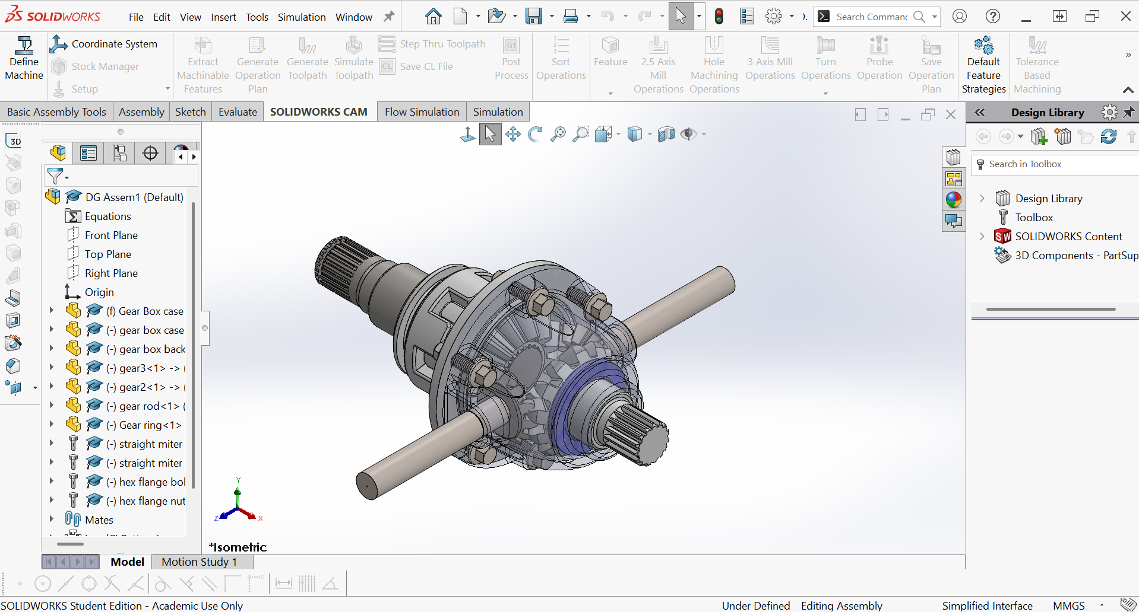

### Module 3: Robotic Gripper – Servo-Driven Mechanism

Servo-driven robotic gripper mechanism developed to demonstrate mechanical motion logic and automation-related design. Includes gears, linkages, gripper arms, covers, and assembly constraints with exploded views.

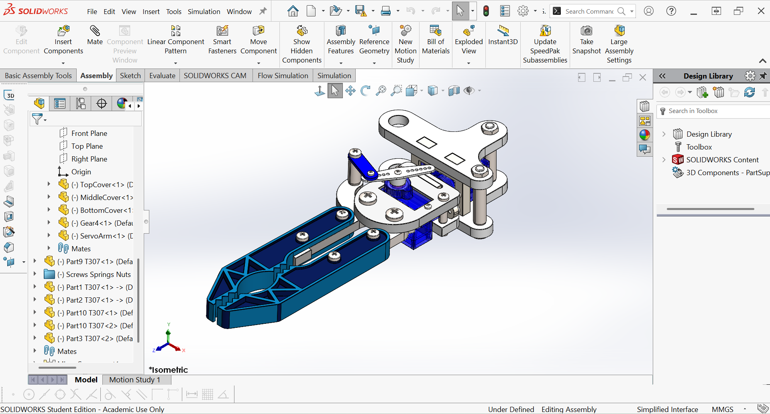

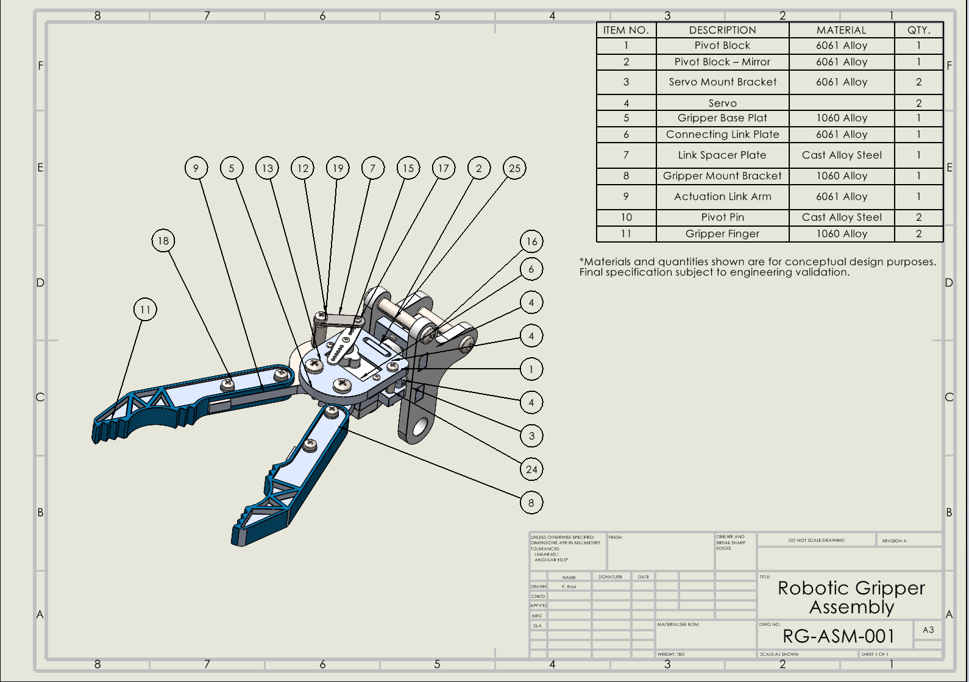

## Engineering Analysis Modules

### Module 4: Truck Chassis – Structural Design with Static FEM

Conceptual truck chassis frame designed and validated using static structural analysis in SolidWorks Simulation. Boundary conditions and loads were applied to evaluate stress distribution and displacement under assumed operating conditions.

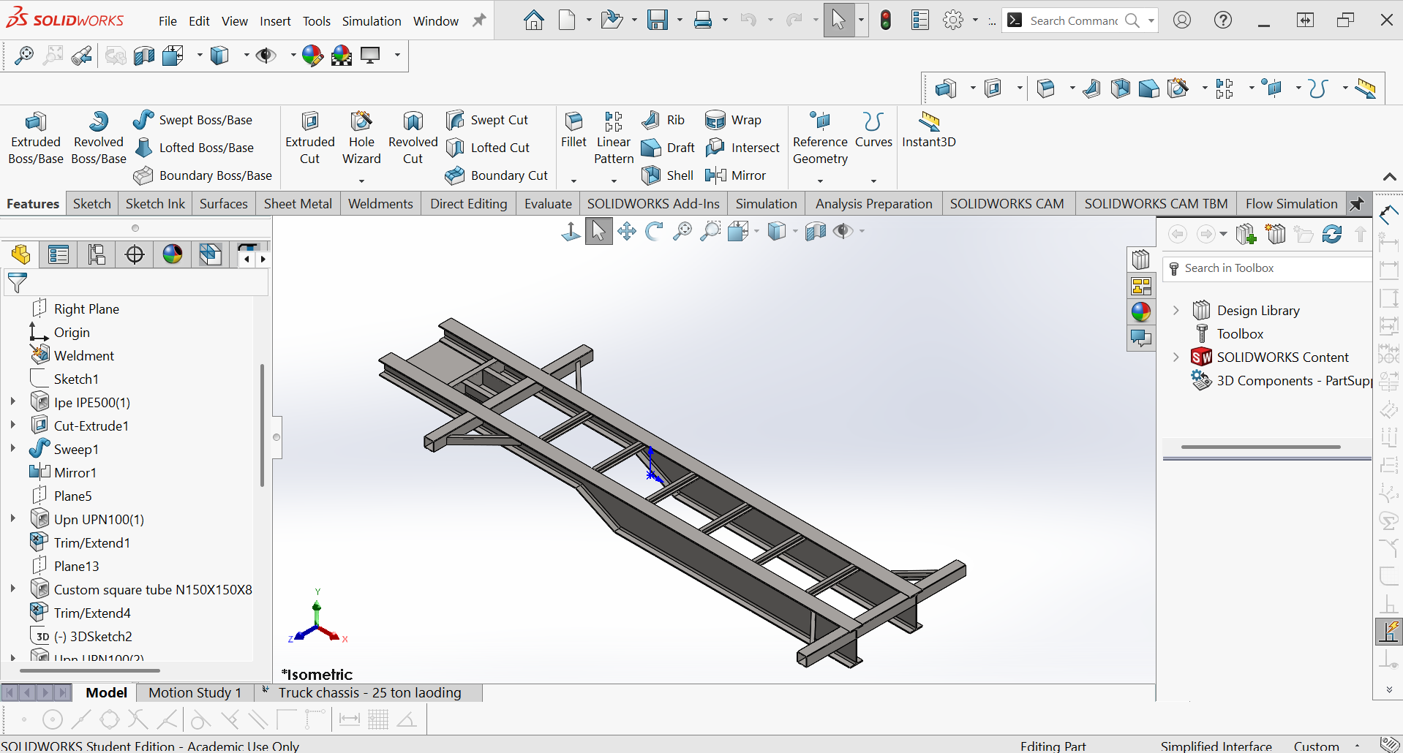

### Module 5: Exhaust Manifold – Flow Simulation (CFD)

Exhaust pipe model analyzed using SolidWorks Flow Simulation to study internal flow behavior. Velocity and pressure contours were evaluated under assumed inlet and outlet conditions to understand flow characteristics.

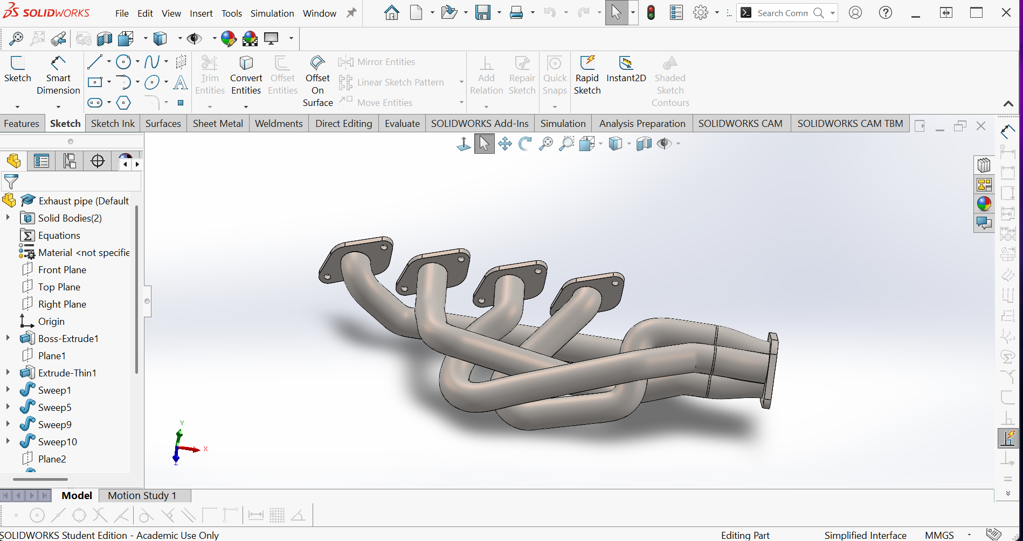

## Supporting & Concept Modules

### Module 6: Gearbox with Housing – Concept Transmission Design

Concept-level gearbox assembly created to demonstrate understanding of gear trains, shaft arrangement, bearing placement, and housing layout. This module supports mechanical transmission knowledge.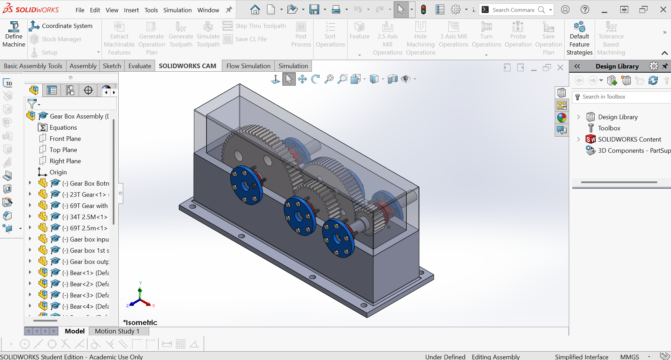

### Module 7: UAV / Fixed-Wing Drone – Concept CAD Model

Fixed-wing UAV concept model developed to demonstrate 3D CAD skills, symmetry, and overall airframe layout. The model focuses on external geometry and packaging rather than detailed aerodynamic validation.

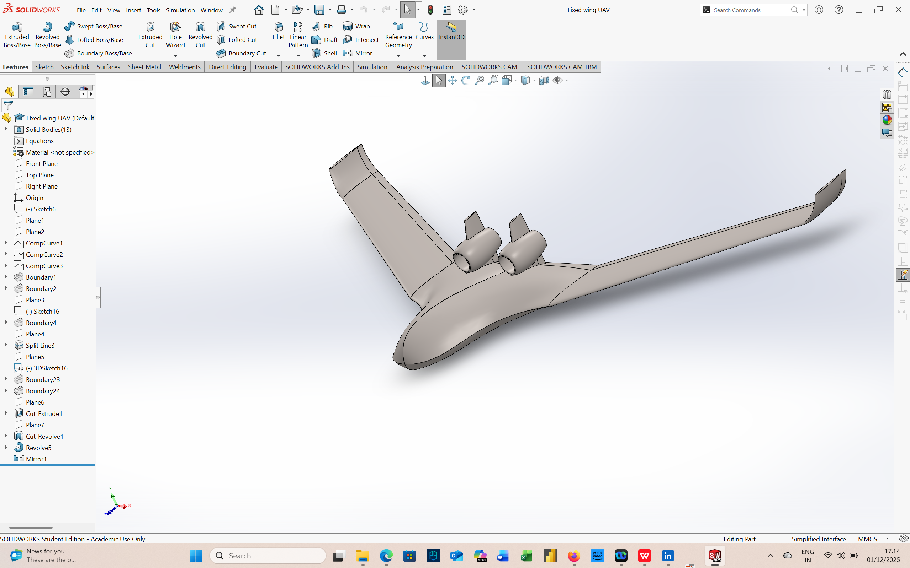

### Module 8: Multirotor Drone – Mechanical Layout Concept

Multirotor drone concept focusing on frame layout, motor mounting locations, symmetry, and balance considerations. Included as a conceptual mechanical layout project.

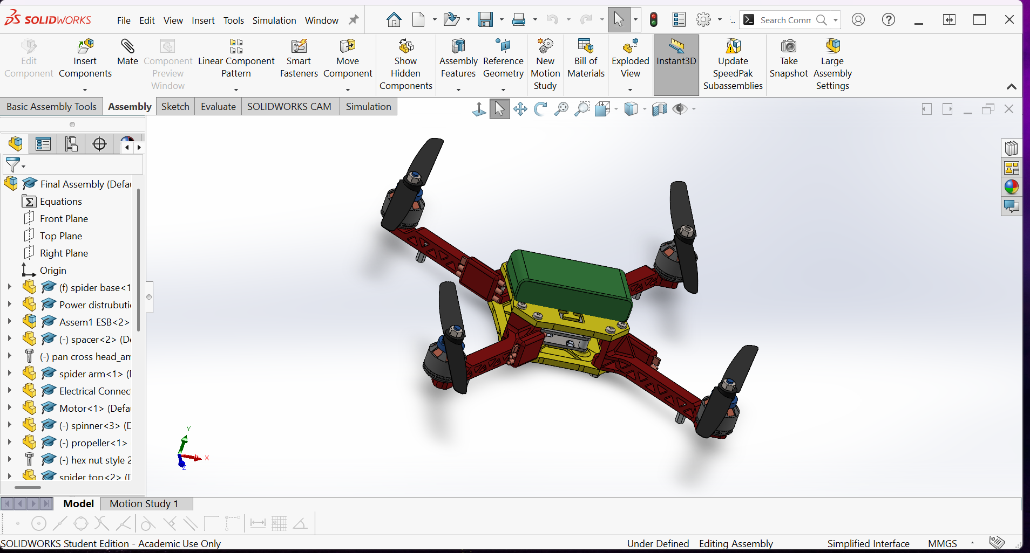

### Module 9: Exhaust Manifold – Complex Geometry CAD

Automotive exhaust manifold modeled to demonstrate handling of complex geometry, solid and surface modeling techniques, and smooth flow-based shapes. Included as a concept CAD project.



### Module 10: Missile / Projectile – Concept CAD Model

Educational concept CAD model created to demonstrate basic aerodynamic shape modeling and parametric design skills. Included strictly as a visual and educational concept.

